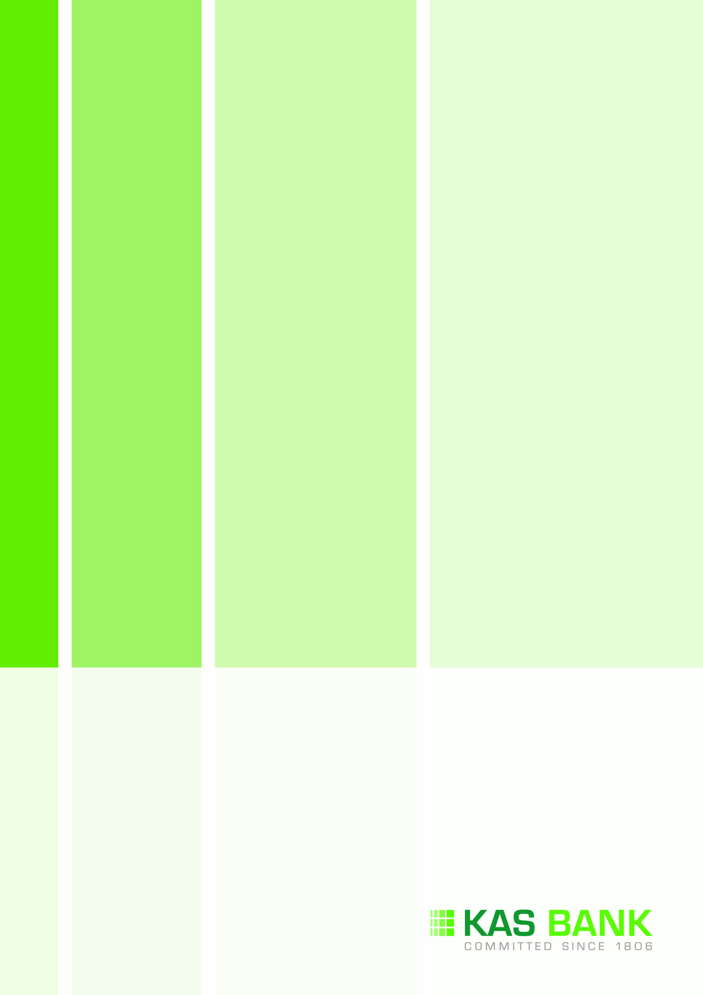

**KAS BANK N.V.**

**REPORT ON THE FIRST HALF OF 2014**

**Contents**

Report on the first half of 2014 3

Condensed consolidated income statement 9

Condensed consolidated statement of comprehensive income 10

Condensed consolidated balance sheet 11

Condensed consolidated statement of changes in equity 12

Condensed consolidated cash flow statement 13

Selected explanatory notes to the report on the first half of 2014 14

Review report 18

# Report on the first half of 2014

**Chairman’s statement**

KAS BANK achieved a satisfactory result in the first half of 2014. Market conditions deteriorated in the second quarter, resulting in negative interest rates from the ECB and volatile securities markets, with volumes a long way from the levels before the credit crisis. The interest rate and liquidity policies of the ECB aim to stimulate lending. This also leads to the (unintended) effect that institutional investors with a low risk profile, such as pension funds and insurance companies, are hardly able to make a return on their exposures.

KAS BANK is also affected as the bank manages the liquidity positions of its customers. The lower income from Treasury is caused by the abundance of (centrally directed) liquidity in the market, because parties are unable to generate additional return on their liquidity surplus. However, by means of an active policy within the strict risk framework, KAS BANK has been able to increase its interest income in 2014. Moreover, as a result of declining interest rates, the revaluation reserve of the bank’s AFS portfolio increased by more than € 4 million this half year.

At the end of 2013 KAS BANK refocused on four institutional core segments, which are pension funds, insurance companies, funds and wealth (private banks, asset managers, charities). It is positive that the bank has realised a healthy increase in activity mainly in the pension fund core segment, resulting in revenue growth and a significant increase of the Assets under Administration. This growth has been achieved mainly in the Netherlands and the United Kingdom. KAS BANK expects to expand its role in the pension market in the coming years by offering additional services to pension funds, such as collateral management, derivatives services, order execution, cost management and other forms of fiduciary management. KAS BANK’s independent and neutral business model offers institutional parties transparency and insight into the overall cost of managing assets, which can lead to substantial savings.

As an active player in the Netherlands, Germany and the United Kingdom, KAS BANK is increasingly involved in complex infrastructural services such as the management of broadly diversified investment administrations. Despite far-reaching harmonisation being pursued in Europe, knowledge of local reporting requirements, local regulations and systems is an important advantage for KAS BANK. The bank now manages approximately € 110 billion of assets on its central platform and expects continuing growth.

In Germany in 2013, KAS BANK shifted the focus to the institutional market for self-administered pension funds. Unlike other countries in Europe companies in Germany may administer their accrued pension commitments in-house. This custodian bank market, which especially focuses on the middle and large companies in Germany, fits well with the services that KAS BANK is also offering in the Netherlands and the United Kingdom and uses the same systems. In this way, from 2014 onwards, the bank can also reuse its investments in systems in Germany. This will in particular benefit the product range and services offered.

The intensive collaboration with dwpbank, which would have commenced from mid-2015 onwards, has been scaled down on request of dwpbank to a modest support in the German market by KAS BANK. The one-off result of € 15 million after tax (€ 20 million before tax) that has consequently been paid to KAS BANK at the end of June, will to a large extent be reinvested in the further development of the service offered to our institutional core segments. KAS BANK has been operating as a network bank for many years, this strategy will continue unchanged. This implies that KAS BANK will either provide an excellent service on its own platform or outsource parts of the business operations to partners.

At the end of 2013, KAS BANK announced a targeted reduction of operational costs by 15% by the end of 2015. In the first six months of 2014, compared to the same period in 2013, operating expenses have decreased by 13%, slightly ahead of targets. The savings have been primarily achieved through lower personnel and housing expenses.

**Results**

KAS BANK recorded a net result of € 21.2 million in the first six months of 2014, up almost 150% compared to the first half of 2013 (€ 8.5 million). The result from operations increased by more than 15% to € 6.9 million (H1 2013: € 6.0 million), including sales from the AFS portfolio of € 2.3 million (H1 2013: € 5.1 million). Non-operating items (H1 2014: € 14.3 million; H1 2013: €2.5 million) caused the difference between the net result and the result from operations. Non-operating items included the compensation from dwpbank as a result of the scale down of the collaboration (€ 15 million, after tax) and the resolution levy related to the nationalisation of SNS Reaal (€ -0.7 million, not tax deductable).

Return on equity in H1 2014 amounted to 20% (H1 2013: 9%) and the efficiency ratio was 61% (H1 2013: 88%).

**Income**

Income increased by 22% to € 73.6 million in H1 2014 (H1 2013: € 60.3 million). Lower commission income and lower returns on investments were offset mostly by one-off items (compensation from dwpbank) and partly by higher interest.



*Interest*Interest increased by 23% to € 12.4 million (H1 2013: € 10.1 million), driven by higher volumes and higher margins on investments in the investment portfolio.

*Commission income*

Commission income decreased by 4% to € 33.2 million (H1 2013: € 34.7 million).

*Breakdown of commission income*



Asset Servicing commission income (mainly for Custody and Investment Management Services) increased by 3% to € 15.3 million (H1 2013: € 14.9 million). Client wins and an increase in Assets under Administration compensated for impact of pressure on fee levels as well as the closure of the KAG activities in Germany. The first results from services related to the AIFMD (in effect from 22 July 2013, mandatory from 22 July 2014) also resulted in higher income. The Assets under Administration increased by 16% to € 360 billion (June 2013: € 311 billion), due to client wins and autonomous growth.

The 4% decrease in Transaction Servicing commission income to € 11.7 million (H1 2013: € 12.2 million) was the result of lower volumes mainly in off-exchange settlements of (non-)listed financial instruments.

Treasury income decreased by 18% to € 6.2 million (H1 2013: € 7.6 million), primarily due to a market wide liquidity surplus putting pressure on prices in the securities lending market.

*Result on investments  
Breakdown of result on investments*



The main part of the result on investments consisted of client-driven foreign exchange transactions. This remained stable at € 4.7 million in H1 2014 in comparison with H1 2013 (€ 4.8 million). The trading results on securities and derivatives are mainly caused by interest derivatives, which mitigate interest risk of part of the investment portfolio.

The result on investments of the investment portfolio consisted of sales of bonds and price increases for bonds for which impairments were recorded in 2008. The revaluation reserve for the investment portfolio increased by € 4.2 million in the first half of 2014 (H1 2014: € 9.4 million; year-end 2013: € 5.2 million) due to lower interest rates and decreasing credit spreads.

*Share of result of associates and joint operations*

The result of associates and joint operations decreased with € 1.6 million to € 0.3 million negative (H1 2013: € 1.3 million positive). The results related to the share of KAS BANK in its participations. In H1 2013 the purchase below book value of a stake in Neonet contributed € 1.5 million to the presented result.

*Other income*

Other income increased by € 19.8 million to € 20.8 million (H1 2013: € 1.0 million). In June 2014 KAS BANK and dwpbank scaled down their European collaboration. As a compensation for the loss of the anticipated annual savings that KAS BANK would have realised from mid-2015 onwards, dwpbank paid KAS BANK a compensation of € 20 million in June 2014.

**Operating expenses**

Operating expenses (excluding impairments) decreased by 13% (H1 2014 € 44.7 million; H1 2013: € 51.5 million), reflecting the restructuring programme which started in the first quarter of 2014. All expenses contributed to this decrease, with the exception of general and administrative expenses. General and administrative expenses increased by 31% due to the one-off resolution levy related to the nationalisation of SNS Reaal (H1 2014: € 0.7 million; H1 2013: nil) and higher consultancy costs.

The impairments related to credit facilities. The negative effect of impairments on the H1 2014 result amounted to € 0.2 million (H1 2013: negative € 1.5 million).

**Tax expenses**

The higher effective tax rate of 26% (statutory tax rate: 25%) is mainly due to the write-down of a tax asset and the non-deductibility of the resolution levy. In the first half of 2013 the tax expense contributed positively to the net profit of € 1.3 million, as a result of positive tax effects of the closure of KAG activities in Germany.

**Quality of the investment portfolio**

The table below shows investment portfolio securities which are classified as investments available for sale, investments at fair value through profit or loss and investments held to maturity according to credit rating (Moody’s Investor Services).



**Solvency (capital ratios)**



*\* The comparative figures are based on Basel II*

High capital ratios reflect KAS BANK’s low risk profile. Following the implementation of the Capital Requirement Regulation (CRR, implementing Basel III) on 1 January 2014, KAS BANK’s Tier 1 and capital ratio were 22% at the end of June 2014. As per 31 December 2013 both ratios would be 27%, based on the new CRR.

**Liquidity**

The table below shows the cash flows (not discounted) for the financial assets based on the contractual maturity date.





The high level of liquidity is shown by the fact that, as at 30 June 2014, 75% of the investments had a maximum maturity of three months (31 December 2013: 70%).

The average liquidity surplus based on the Financial Supervision Act was € 0.9 billion in the second quarter of 2014 (31 December 2013: € 1.1 billion).

**Dividend**  
The interim dividend will remain at € 0.33, in line with prior years.

Of the compensation received from dwpbank 80% will be invested in improving the operational environment and will therefore not be paid out as dividend. Barring unforeseen circumstances, for the remaining part the regular dividend policy with a pay-out ratio of 60-80% applies.

**Outlook**Market perspectives in Europe are volatile. The expectation that interest levels will increase is low. Unrest due to political instability, as has been the case over the past few months, usually leads to lower transaction volumes.

On 22 July the AIFM Directive entered into force in Europe. This directive requires fund managers not regulated by UCITS-4 to appoint a separate custodian. For KAS BANK the impact of this directive will result in a few percentage points of additional revenue growth in the second half of 2014.

**Statement of compliance**  
The Managing Board hereby declares that, to the best of its knowledge, the report on the first half of 2014,

prepared in accordance with IAS 34 ‘Interim Financial Reporting’, provides a true and fair view of the company’s position on the balance sheet date and that the report on the first half of 2014 provides an accurate overview of the information required pursuant to Section 5, subsection 25d, paragraphs 8 and 9, of the Financial Supervision Act.

Amsterdam, 28 August 2014

Managing Board

A.A. Röell, chairman

K.H.J. Wulteputte, CFRO

S.A.J. van Katwijk

# Condensed consolidated income statement



The accompanying notes form an integral part of the condensed consolidated interim financial statements.

# Condensed consolidated statement of comprehensive income



# Condensed consolidated balance sheet



# Condensed consolidated statement of changes in equity



# Condensed consolidated cash flow statement



# Selected explanatory notes to the report on the first half of 2014

**Corporate information**KAS BANK N.V. is a public limited liability company, incorporated under Dutch law and registered in Amsterdam, the Netherlands. KAS BANK’s condensed consolidated financial statements for the period ending   
30 June 2014 include the parent company and all its subsidiaries, together referred to as ‘KAS BANK’. An overview of the principal subsidiaries is included in the 2013 annual report.

The interim financial statements were prepared by the Managing Board and approved by the Supervisory Board and Managing Board on 28 August 2014.

**Basis of presentation**

The condensed consolidated financial statements for the period ending 30 June 2014 are presented in accordance with IAS 34 ‘Interim Financial Reporting’, as adopted by the European Union. This interim report does not include all information and disclosures required in annual financial statements and should therefore be read in conjunction with the 2013 annual report. The financial statements are presented in euros, which is the functional currency of KAS BANK, rounded to the nearest thousand (unless stated otherwise).

In preparing the condensed consolidated figures for the first half of 2014, the same critical accounting estimates and judgements are used as for the consolidated 2013 financial statements.

These condensed consolidated interim financial statements have been reviewed and not audited.

**Changes in accounting policies**

The accounting policies applied in these interim financial statements are consistent with those used for the 2013 financial statements except for the following non-significant adjustments:

* IFRS 10: Consolidated Financial Statements;
* IFRS 11: Joint Arrangements;
* IFRS 12: Disclosures of Interests in Other Entities;
* IAS 27: Separate Financial Statements;
* IAS 28: Investments in Associates and Joint Ventures;
* Amendments to IFRS 10, IFRS 11 and IFRS 12: Transition Guidance;
* Amendments to IFRS 10, IFRS 12 and IAS 27: Investment Entities;
* Amendments to IAS 32: Offsetting Financial Assets and Financial Liabilities;
* Amendments to IAS 36: Recoverable Amount Disclosures for Non-Financial Assets;
* Amendments to IAS 39: Novation of Derivatives and Continuation of Hedge Accounting;
* IFRIC Interpretation 21: Levies.

**New IFRS standards and interpretations not yet adopted**

A number of new, amended or revised standards were not applied in preparing these financial statements as these standards were not effective for the current period or have not been adopted by the European Union. These standards will have an impact on the preparation of the financial statements in the near future. These new, amended or revised standards are listed below.

*IFRS 9 Financial instruments*

The new standard contains requirements for financial assets and financial liabilities. The requirements include topics like classification and measurement, impairment methodology and hedge accounting. The new standard will replace the existing requirements as included in the current IAS 39 Financial instruments: recognition and measurement.

The effective date of the new standard is 1 January 2018. The standard is not yet endorsed by the European Union. The expected impact of IFRS 9 will be significant.

In addition to the above-mentioned significant changes, a number of new, amended and revised standards are expected not to have a significant impact on KAS BANK’s financial results and position in the near future.

These amendments, revisions and new standards are:

* Amendments to IAS 19: Defined Benefit Plans: Employee Contributions, effective as of July 2014;
* Annual improvements to IFRSs (2010-2012 cycle), effective as of July 2014;
* Annual improvements to IFRSs (2011-2013 cycle), effective as of July 2014;
* Amendments to IAS 16 and IAS 38: Clarification of Acceptable Methods of Depreciation and Amortisation, effective as of 2016;
* Amendments to IAS 16 and IAS 41: Agriculture: Bearer Plants, effective as of 2016;
* IFRS 14: Regulatory Deferral Accounts, effective as of 2016;
* IFRS 15: Revenue from Contracts with Customers, effective as of 2017.

**Fair value measurement**

The following table presents the financial instruments carried at fair value, broken down according to the fair value hierarchy. The fair value hierarchy distinguishes three levels of fair value:

* Level 1: Unadjusted quoted prices obtained in an active and liquid market;
* Level 2: Valuation techniques based on observable market data other than quoted prices included in level 1;
* Level 3: Valuation techniques using variables other than observable market data.

Some equity instruments are measured at historical cost since no market data exists.

There were no changes in valuation techniques during the period.





*Reclassifications from level 2*

In the first half of 2014 we were able to obtain unadjusted quoted prices in an active and liquid market for some instruments formerly classified as level 2. As a consequence we transferred assets with a fair value of € 164.9 million from level 2 to level 1.

*Reconciliation of fair value at level 3*

The movements in financial instruments measured using a level 3 method were as follows:



The level 3 assets consist of a few financial instruments. One instrument is valued by a third party and represents a fair value of € 1.0 million. The other holdings are based on an analysis of the assets and liabilities and represent a fair value of € 1.2 million.

**Dividend**

After the General Meeting of Shareholders of 23 April 2014, the proposed final dividend for 2013 of   
€ 4.6 million (€ 0.31 per share) was distributed to the shareholders in the first half of 2014.

**Investments in associates and joint operations**

At 30 June 2014 KAS BANK obtained all shares in Secpoint N.V., the joint operation of KAS BANK and dwpbank. KAS BANK bought the 50%-interest from dwpbank at fair value. As a consequence Secpoint is no longer classified as a joint operation as of 30 June 2014. The result for the first half of 2014 is classified as ‘Share of result of associates and joint operations’.

**Other liabilities**

A restructuring provision was recognised in 2013, which is aimed at structural improvement of the results as of 2014. The restructuring programme started in the first quarter of 2014. As per June 2014 20% (€ 1.0 million) of the restructuring provision is paid to employees in the restructuring programme, the other 80% (€ 3.7 million) is allocated.

**Other income**

In June 2014 KAS BANK and dwpbank scaled down their European collaboration. As a compensation for the loss of the anticipated annual savings that KAS BANK would have realised from 2016 onwards, dwpbank paid KAS BANK a compensation of € 20 million in June 2014.

**Off balance sheet commitments**

As per June 2014 KAS BANK has committed € 100 million (31 December 2013: nil) to an investment fund (that invests in Dutch residential mortgages). Payment is due in the third quarter of 2014.

**Client segmentation**

KAS BANK’s products and services primarily focus on two main target groups: Institutional Investors and Financial Institutions. Another important activity at KAS BANK is Treasury. This segmentation overview reflects the structure of the internal management information provided to the Managing Board.





*1) Interest income and expense is allocated to the financial institutions and institutional investors segments on the basis of the difference between the external interest rates and benchmarks. The benchmarks are based on interbank or central bank rates.*

# Review report

**To: the Managing Board and Supervisory Board of KAS BANK N.V.**

**Introduction**

We have reviewed the accompanying condensed consolidated interim financial information for the six-month period ended 30 June 2014 of KAS BANK N.V., Amsterdam, which comprises the condensed consolidated balance sheet as at 30 June 2014, the condensed consolidated income statement, the condensed consolidated statement of comprehensive income, the condensed consolidated statement of changes in equity, the condensed consolidated cash flow statement and the selected explanatory notes for the six-month period then ended. The Managing Board is responsible for the preparation and presentation of this condensed consolidated interim financial information in accordance with IAS 34, ‘Interim Financial Reporting’ as adopted by the European Union. Our responsibility is to express a conclusion on this interim financial information based on our review.

**Scope**

We conducted our review in accordance with Dutch law including standard 2410, Review of Interim Financial Information Performed by the Independent Auditor of the company. A review of interim financial information consists of making inquiries, primarily of persons responsible for financial and accounting matters, and applying analytical and other review procedures. A review is substantially less in scope than an audit conducted in accordance with auditing standards and consequently does not enable us to obtain assurance that we would become aware of all significant matters that might be identified in an audit. Accordingly, we do not express an audit opinion.

**Conclusion**

Based on our review, nothing has come to our attention that causes us to believe that the accompanying condensed consolidated interim financial information as at 30 June 2014 is not prepared, in all material respects, in accordance with IAS 34, ‘Interim Financial Reporting’ as adopted by the European Union.

Rotterdam, 28 August 2014

PricewaterhouseCoopers Accountants N.V.

Original has been signed by drs. S. Barendregt-Roojers RA