RoodMicrotec – a profound view into wafer structures and their quality
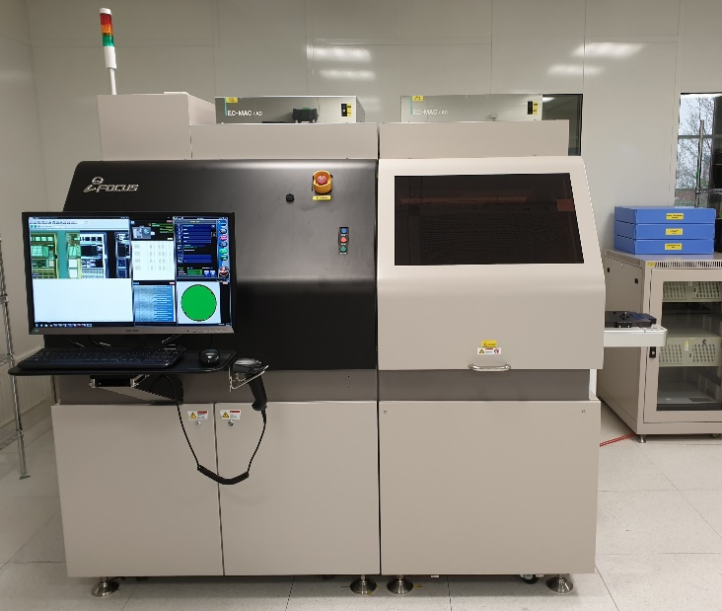
Zwolle, 11th April 2019 – RoodMicrotec N.V., the leading independent company for semiconductors supply and quality services, publishes today that a new automatic optical inspection (AOI) system for semiconductor wafers has been installed to the RoodMicrotec test facility in Nördlingen. Starting in the first quarter of 2019 the STI iFocus 505, a state-of-the-art system, adds a wide range of new possibilities to the company’s portfolio of services.
The industry’s requirements are quickly developing towards a full automation of processes. With this new capability, RoodMicrotec will have a solution that fits the needs of the customers, especially in the automotive sector.
Martin Sallenhag, CEO of RoodMicrotec says: “The purpose of this service is to detect failures and damages on incoming wafers and assurance of quality on outgoing wafers. It will enable us to identify possible defects resulting from earlier processing steps, such as wafer manufacturing and transport, and deliver products of the best possible quality to our customers. We will furthermore be able to stand out as a strong, reliable and quality-delivering partner for all customers in the semiconductor industry by implementing this kind of machine into the existing production landscape.”
The AOI system is able to automatically handle 6, 8 and 12-inch wafers from cassette to cassette. It also offers the possibility to handle and inspect whole or partial wafers, mounted on film frame.
The two main parts of the system are the handling-unit and the vision-unit. The handling-unit consists of a robot that handles the wafers and guides them from the cassette to the vision-unit. The vision-unit includes the movable chuck on high precision linear motors, and the powerful vision system right on top of it. The complete system is mounted on a block of granite weighing half a ton and lying on four air dampers to provide the necessary stability and to compensate vibrations.
The throughput of the system depends on the magnification applied. Mainly 5X is used but the machine is also capable of 2.5X, 3.5X, 7.5X and 10X. The magnification determines the size of defects that can be detected. At 10X for example, defects of the size of 1.6µm x 1.6µm can be found.

About RoodMicrotec
RoodMicrotec is a leading independent company for semiconductor supply and quality services. With 50 years’ of experience in the semiconductor and electronics industry, RoodMicrotec is well-established as a highly valued partner for many companies worldwide. The company provides full-turnkey ASIC services for complex microchips that are customized to handle specific applications for individual customers. In cooperation with strong partners, RoodMicrotec manages the entire development and production flow of ASICs in the target volume, ranging from low quantities up to multiple millions per year. The turnkey solution includes project management, wafer test, assembly, final test, qualification, failure analysis and logistics. All services comply with the industrial and quality requirements of the high reliability, aerospace, automotive, healthcare and industrial sectors. RoodMicrotec’s headquarter is located in Zwolle, Netherlands, with operational units in Nördlingen and Stuttgart, Germany.
For more information visit https://www.roodmicrotec.com

Further information
Martin Sallenhag - CEO, Reinhard Pusch - COO, Arvid Ladega - CFO
Telephone: +31 38 4215216 Email: investor-relations@roodmicrotec.com Web: www.roodmicrotec.com

This press release is published in English, Dutch and German. In case of conflict between these versions the English version shall prevail.
This communication contains information that qualifies as inside information within the meaning of Article 7(1) of the EU Market Abuse Regulation. The company’s managing director and CEO Martin Sallenhag, is responsible for arranging for the release of this document on behalf of RoodMicrotec.

