RoodMicrotec appoints KERR as representative in the Italian market
Deventer, 26th September 2019 – RoodMicrotec N.V., a leading independent company for semiconductors supply and quality services, today announces the appointment of KERR as sales representative in Italy.
Mr. Andrea Stona, CEO of KERR s.r.l. and Mr. Jan de Koning Gans, Managing Director of RoodMicrotec GmbH, have signed a contractual agreement under which KERR will carry out the tasks of promotion and sales of the services offered by the RoodMicrotec in the Italian market.
RoodMicrotec offers ASIC supply chain services as well as qualification, test and failure analysis services for semiconductor components. KERR will be using their presence, knowledge and network in Italy to promote and sell these services.
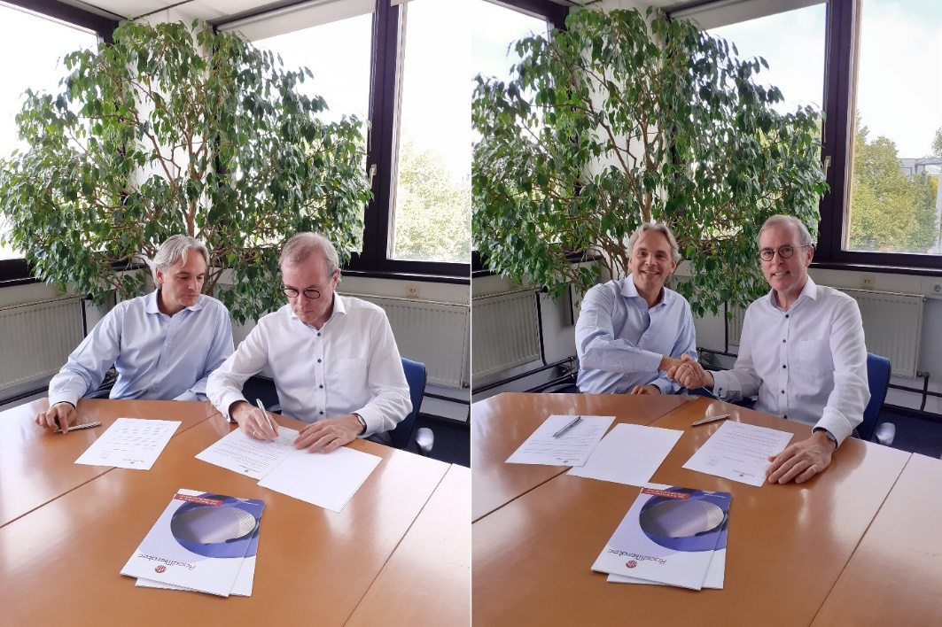
(from the left: Andrea Stona, Jan de Koning Gans)

About KERR
KERR s.r.l. was founded in 2008 in Bolzano, Italy. They act as sales representative for various companies for microelectronic and lighting applications, with high capability in ASIC and FPGA design. Based on over 10 years of experience as engineers, they support the development of ASIC, PCBA and FPGA Design. Capabilities extend from low power design to mix analog/digital ASIC implementation, and to security IP. KERR is headquartered in Bolzano, Italy.
Further information on KERR at http://www.kerr-italy.it/
About RoodMicrotec
RoodMicrotec is a leading independent company for semiconductor supply and quality services. With 50 years of experience in the semiconductor and electronics industry, RoodMicrotec is well-established as a highly valued partner for many companies worldwide. The company provides full-turnkey ASIC services for complex microchips that are customized to handle specific applications for individual customers. In cooperation with strong partners, RoodMicrotec manages the entire development and production flow of ASICs in the target volume, ranging from low quantities up to multiple millions per year. The turnkey solution includes project management, wafer test, assembly, final test, qualification, failure analysis and logistics. All services comply with the industrial and quality requirements of the high reliability, aerospace, automotive, healthcare and industrial sectors. RoodMicrotec’s headquarter is located in Deventer, Netherlands, with operational units in Nördlingen and Stuttgart, Germany.
For more information visit https://www.roodmicrotec.com

Abbreviations
ASIC Application Specific Integrated Circuit
FPGA Field Programmable Gate Array
PCBA Printed Circuit Board Assembly

Further information
Martin Sallenhag - CEO, Arvid Ladega - CFO
Telephone: +31 570 745623 Email: investor-relations@roodmicrotec.com Web: www.roodmicrotec.com

This press release is published in English, Dutch and German. In case of conflict between these versions the English version shall prevail.
This communication contains information that qualifies as inside information within the meaning of Article 7(1) of the EU Market Abuse Regulation. The company’s managing director and CEO Martin Sallenhag, is responsible for the release of this document on behalf of RoodMicrotec.

