RoodMicrotec and Totech to jointly offer Long-Term Storage services
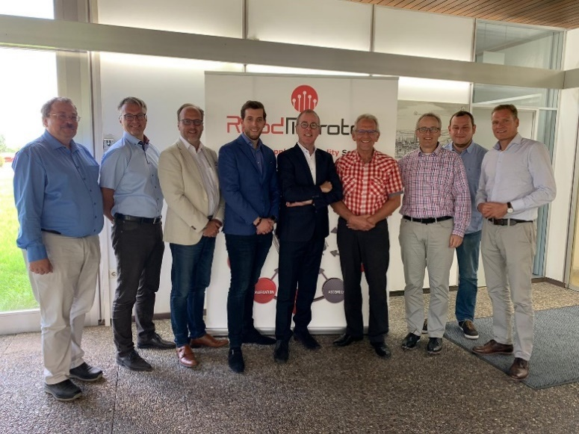
Deventer, 10th October 2019 – RoodMicrotec N.V, a leading independent company for semiconductors supply and quality services, today announces the cooperation with Totech Europe B.V., a Dutch company and world leading manufacturer of storage and humidity control solutions under their trademark Super Dry Totech.
(from the left: Klaus Dittmann, Martin Sallenhag, Jos Brehler, Dave Brehler, Jan de Koning Gans, Dieter Schreiber, Michael Witt, Timo Steinmeyer, Andre Rinne)
Under the cooperation agreement, the parties will be offering long-term storage and related quality testing services of semiconductor components. The partnership is based on core strengths of the two companies and both sides will take full advantage of it. Totech provides long-term storage of materials and components at their facilities in Zwolle, the Netherlands. RoodMicrotec will be providing electrical tests and physical analyses of semiconductor components prior to storage, as well as periodic quality monitoring during storage and before shipping components back to the customer.
Jan de Koning Gans, Managing Director of RoodMicrotec GmbH, says: “There is obviously a growing need for long-term storage services of semiconductor components in various markets. Storing of components for a larger number of years, is an important part of Obsolescence Management strategies. Totech is a market leader in cost-efficient long-term storage solutions. RoodMicrotec is leading in semiconductor component quality assessment services. By joining our forces, we bring a complete and competitive service model to the market.”
Jos Brehler, CEO of Totech, says: “At Super Dry Totech, we’re always looking for new ways to help our customers compete more effectively. Our customers already know we’re handling & storage specialists with unparalleled expertise in the preservation of MSDs in a production environment. But now they are also finding that our long term storage facility in Zwolle is proving extremely valuable for managing long term storage and the fight against obsolescence. With this latest partnership Totech customers enjoy all the customer service, account management and storage capabilities of Totech, combined with the rigorous testing and analysis of stored components by RoodMicrotec, to ensure their continued quality and reliability. “

About Totech
Totech is a Moisture Sensitive Device (MSD) handling & storage specialist. Their dry storage solutions deliver a low, controlled level of humidity (<0.5%). Moisture absorbent materials including electronic components, PCBs (printed circuit boards), nano fibers, contact lenses, laboratory samples, 3D printing polymers and other vulnerable materials are kept dry and free from water ingress. Totech is headquartered in Zwolle, the Netherlands.
Further information on Totech at https://www.superdry-totech.com/

About RoodMicrotec
RoodMicrotec is a leading independent company for semiconductor supply and quality services. With 50 years of experience in the semiconductor and electronics industry, RoodMicrotec is well-established as a highly valued partner for many companies worldwide. The company provides full-turnkey ASIC services for complex microchips that are customized to handle specific applications for individual customers. In cooperation with strong partners,
RoodMicrotec manages the entire development and production flow of ASICs in the target volume, ranging from low quantities up to multiple millions per year. The turnkey solution includes project management, wafer test, assembly, final test, qualification, failure analysis and logistics. All services comply with the industrial and quality requirements of the high reliability, aerospace, automotive, healthcare and industrial sectors. RoodMicrotec’s headquarter is located in Deventer, Netherlands, with operational units in Nördlingen and Stuttgart, Germany.
For more information visit https://www.roodmicrotec.com

Further information
Martin Sallenhag - CEO, Arvid Ladega - CFO
Telephone: +31 570 745623 Email: investor-relations@roodmicrotec.com Web: www.roodmicrotec.com

This press release is published in English, Dutch and German. In case of conflict between these versions the English version shall prevail.

