Press release

Royal BAM Group nv

Composition management Wayss & Freytag Ingenieurbau
Bunnik, the Netherlands, 18 May 2018 – The Executive Board of Royal BAM Group nv has appointed Dr.-Ing. M. Blaschko as chairman of the management (Vorstandsvorsitzender) of Wayss & Freytag Ingenieurbau AG effective 1 August 2018. Michael Blaschko (49) is part of the management board of BAM’s German civil engineering company since 2009.

Mr Blaschko succeeds Mr B.J. Wierenga (61) , who will step down from Wayss & Freytag Ingenieurbau as of the same date. The Executive Board is grateful to Mr Wierenga for the dedication and commitment with which he has successfully led Wayss & Freytag Ingenieurbau over the past four years. In the coming period he will head 'The BAM Way' programme, which is part of the strategic agenda of BAM and focuses on the development of a uniform method for the critical processes of large projects and the strengthening of the business information systems.

The Executive Board has also appointed Dipl.-Geol. Th. Paetzold as director (Vorstandsmitglied) of Wayss & Freytag Ingenieurbau as per 1 June 2018. Thomas Paetzold (59) is currently managing Wayss & Freytag Ingenieurbau’s environmental services and renovations subsidiary. He joined the company in 1989 as an environmental geologist and has held various management positions since then.
With effect from 1 August 2018 the management of Wayss & Freytag Ingenieurbau will consist of Dr.-Ing. M. Blaschko, chairman, Dipl.-Geol. Th. Paetzold and Dipl.-Ing. Dipl.-Wirtsch.-Ing. I. Rojczyk.

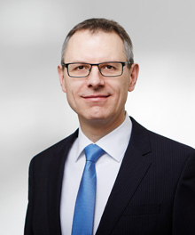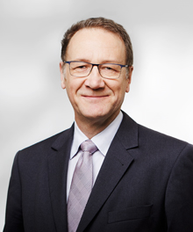
Dr.-Ing. Michael Blaschko. Dipl.-Geol. Thomas Paetzold.

Further information:
- press: Arno Pronk, +31 (0)30 659 86 23, arno.pronk@bam.com;
- analysts: Joost van Galen, +31 (0)30 659 87 07, joost.van.galen@bam.com.

AP/gc/18/0014e

Koninklijke BAM Groep nv
Runnenburg 9, 3981 AZ Bunnik / PO Box 20, 3980 CA Bunnik, the Netherlands
Telephone +31 (0)30 659 89 88 / Fax +31 (0)30 659 81 50
Trade register 30058019. Corporate seat at Bunnik, the Netherlands

