Press release

Royal BAM Group nv

BAM acquires stake in Irish modular homes specialist MHI

Ballyjamesduff, Co. Cavan / Kill, Co. Kildare, Ireland / Bunnik, the Netherlands, 25 January 2019 – Royal BAM Group’s Irish operating company has acquired a non-controlling share in leading modular homes provider Modern Homes Ireland (MHI). MHI constructs quality assured steel-framed homes and commercial buildings within a precision-controlled environment with units being up-to 95 per cent constructed before leaving the factory. Financial terms of the transaction are not disclosed.

BAM has taken the strategic step with MHI – the only NSAI certified volumetric housing provider in Ireland – to enhance and maximise business opportunities for both companies in the Irish construction sector. MHI was established in 2016 and has completed more than 400 residential units since then, mainly in the Leinster area, including a combination of social housing and high-end residential developments. Based in Ballyjamesduff where it employs 120 people with a current capacity of more than 500 units annually, it is led by its founding shareholder team of Joint Managing Directors Chris Curtis and Stephen McManmon and Executive Directors Adrian McNally and Brendan McNally.

With the growing demand for housing, increasing industry resource constraints and the rising level of public and private investment in social and private homes, there is significant opportunity for both to become the leaders in the use of modular construction for housing, student accommodation and hotels. These sectors are an important part of BAM’s current output. Both businesses plan to accelerate home building activity in social housing and PPP contracts as well as in private developments in large population centres. This further development in its modular approach, reflecting the change in the industry and in line with BAM’s strategy Building the present, creating the future, enables BAM to offer its clients added value through high quality and rapid programmes.

MHI has a unique and immediate offering of volumetric housing units and is well positioned to grow significantly in modular construction across multiple streams. They can competitively deliver high quality housing, unaffected by the construction skills shortage currently being experienced in Ireland. The benefit of offsite fabrication is a considerable faster build time than traditional construction.

Following BAM’s investment MHI will further increase its production capacity in Ballyjamesduff.
It will also benefit from BAM Ireland’s widespread knowledge across technical and academic fields and access to the Group’s global innovation team. This will improve its processes from a production and operational efficiency perspective, as well as being able to leverage BAM’s strong client base to enter new markets.

BAM will also bring the expertise and experience which will enable MHI to bid for larger projects. This step also allows MHI access to BAM’s modular expertise in the Netherlands, where BAM Modulair Bouwen en Ontwikkelen has state-of-the art production facilities in Veenendaal to develop innovative elements for newbuild and renovation projects in both the residential and non-residential markets, thus contributing to making buildings more sustainable and circular.

Theo Cullinane, CEO, BAM Ireland said: ‘This is a significant strategic investment for BAM. We are cognisant of the need for an acceleration of output in the housing sector and we are happy that our investment will play a part in the solution to the current housing crisis in the country. Modular is clearly the future and this is a unique opportunity to further develop a business, not just in housing but in modular housing which aligns closely with our drive towards ‘digital construction’.’

Commenting on the deal, MHI Joint Managing Director Chris Curtis said: ‘We are very pleased to have entered into this strategic partnership with an industry leader in BAM, which will allow us to grow further and benefit from the vast experience that they will bring to us. This significant investment further confirms that off-site construction is the future of housing and that our firm is at the forefront. This collaboration is the foundation for an exciting future ahead for MHI.’

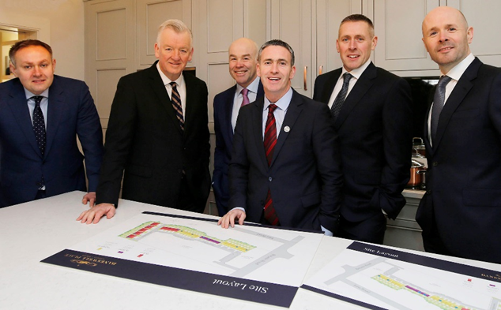
Pictured (from left): Brendan McNally (Executive Director and Co-Founder, MHI), Theo Cullinane (CEO, BAM Ireland), Chris Curtis (Joint MD and Co-Founder, MHI), Minister of State for Housing and Urban Development Damien English T.D., Adrian McNally (Executive Director and Co-Founder, MHI) and Stephen McManmon (Joint MD and Co-Founder, MHI).

About BAM Ireland
BAM Ireland (BAM Contractors Ltd) covers the entire spectrum of construction in Ireland with its subsidiaries BAM Civil, BAM Building, BAM Property, BAM Rail and BAM FM). BAM's revenues in Ireland are €420 million (2017). BAM Ireland currently directly and indirectly employs over 2,500 people. BAM Building ranks among the top two building contractors operating nationally and has carried out projects of the largest scale for the most prestigious of clients. BAM Civil is the largest civil engineering contractor in Ireland. Recent and current projects include PPP motorway schemes, education and legal infrastructure, healthcare, pharmaceutical & industrial, transportation, large-scale commercial, water & wastewater, residential, leisure & accommodation, marine, energy and rail developments.

About Modern Homes Ireland

Modern Homes Ireland (MHI) builds homes in a factory setting, many over 90 per cent complete, delivering and installing the units on site. MHI utilises advanced manufacturing technology and precision engineering, which enables developers to have a completed home on-site within three weeks thus dramatically reducing costs and increasing build potential. MHI began its first delivery of units in late 2016 and has since then completed over 400 residential units and approximately 2,400 modules. MHI employs 120 people. MHI’s manufacturing facilities (20,000 m2) are based in Ballyjamesduff, Co. Cavan.

Further information:
- analysts: Joost van Galen, +31 (0)30 659 87 07, joost.van.galen@bam.com;
- press: Arno Pronk, +31 (0)30 659 86 23, arno.pronk@bam.com.

AP/gc/19/0003e

Royal BAM Group nv
Runnenburg 9, 3981 AZ Bunnik, the Netherlands / PO Box 20, 3980 CA Bunnik, The Netherlands
Telephone +31 00 (0) 30 659 89 88 / Fax +31 00 (0) 30 659 81 50
Trade register The Netherlands 30058019. Registered office in Bunnik, The Netherlands.
www.bam.com

