Press release

Royal BAM Group nv

BAM secures Bolands Quay contract in Dublin

Bunnik, the Netherlands, 15 March 2017 – BAM Contractors Ltd, the Irish operating company of Royal BAM Group nv, has been awarded a contract for the construction of the Bolands Quay Development (formerly Boland’s Mill) in Dublin’s south docklands. The client is Bolands Quay Development Group.
Designed by Dublin’s leading architectural practice, Burke Kennedy Doyle, Bolands Quay will provide three new landmark buildings comprising approximately 36,851 m² (approximately 397,000 sq ft) of office, residential, retail and cultural space.
The development will also involve the restoration of a number of protected mill buildings, the creation of a new civic plaza looking onto the waterfront at Grand Canal Dock and a new pedestrian bridge.

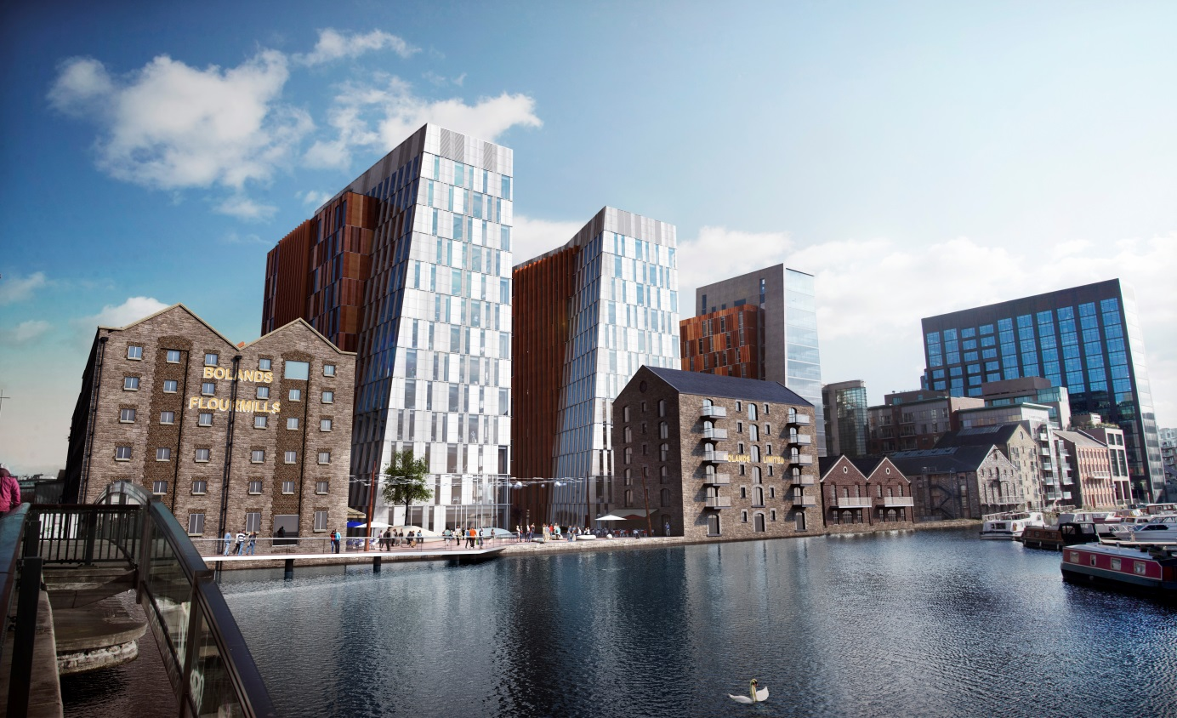

Further information:
- Analysts: Joost van Galen, +31 30 659 87 07, j.van.galen@bamgroep.nl;
- Press: Annet Strietman, +31 30 659 86 23, annet.strietman@bam.com.

AST/pr/17/0016e

Royal BAM Group nv
Runnenburg 9, 3981 AZ Bunnik / PO Box 20, 3980 CA Bunnik, the Netherlands
Telephone +31 30 659 89 88
Trade register The Netherlands 30058019. Established at Bunnik, the Netherlands.
www.bam.com

