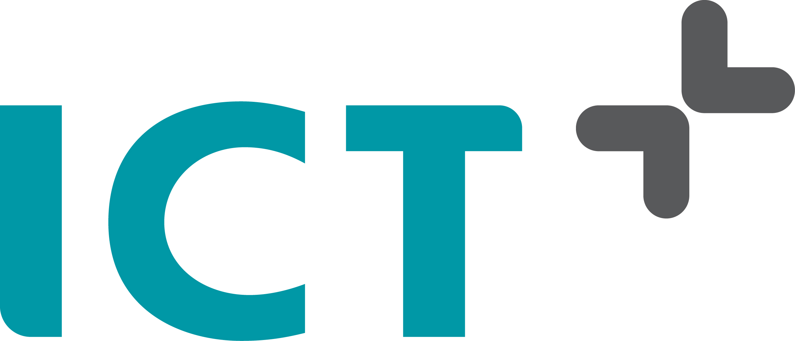

PRESS RELEASE pages: 1

Barendrecht, January 25, 2018

ICT Group completes acquisition of NedMobiel

ICT Group N.V. (ICT) announces that it has completed the purchase of 100% of the shares of NedMobiel B.V., a Dutch expert consultancy company for complex infrastructures. The purchase consideration has been paid in cash.

NedMobiel has extensive expertise in (tunnel) safety, asset management and project management. NedMobiel will work closely with ICT Netherlands’ business units Water and Infrastructures and Engineering Contractors and will be able to benefit from the strong position that ICT holds in the national rail, road, water and infra sectors. This acquisition supports ICT’s transition from a leading software integrator to a total technology and service provider, by increasing revenue from projects as well as from services.
ICT Group N.V. is a leading industrial technology solutions and services provider. Our specific industry knowledge of various markets, enables us to realise innovative solutions. Over 1000 passionate technical specialists are working for the ICT Group. The following subsidiaries are the main operating entities of the ICT Group: ICT Netherlands (ICT Automatisering Nederland B.V.), Strypes Bulgaria (Strypes EOOD ltd), Raster (Raster Industriele Automatisering B.V. and Raster Products B.V.), Improve (Improve Quality Services B.V.), BMA (Buro Medische Automatisering B.V.) (51%), ICT Mobile B.V. (51%). For more information: www.ict.eu.

